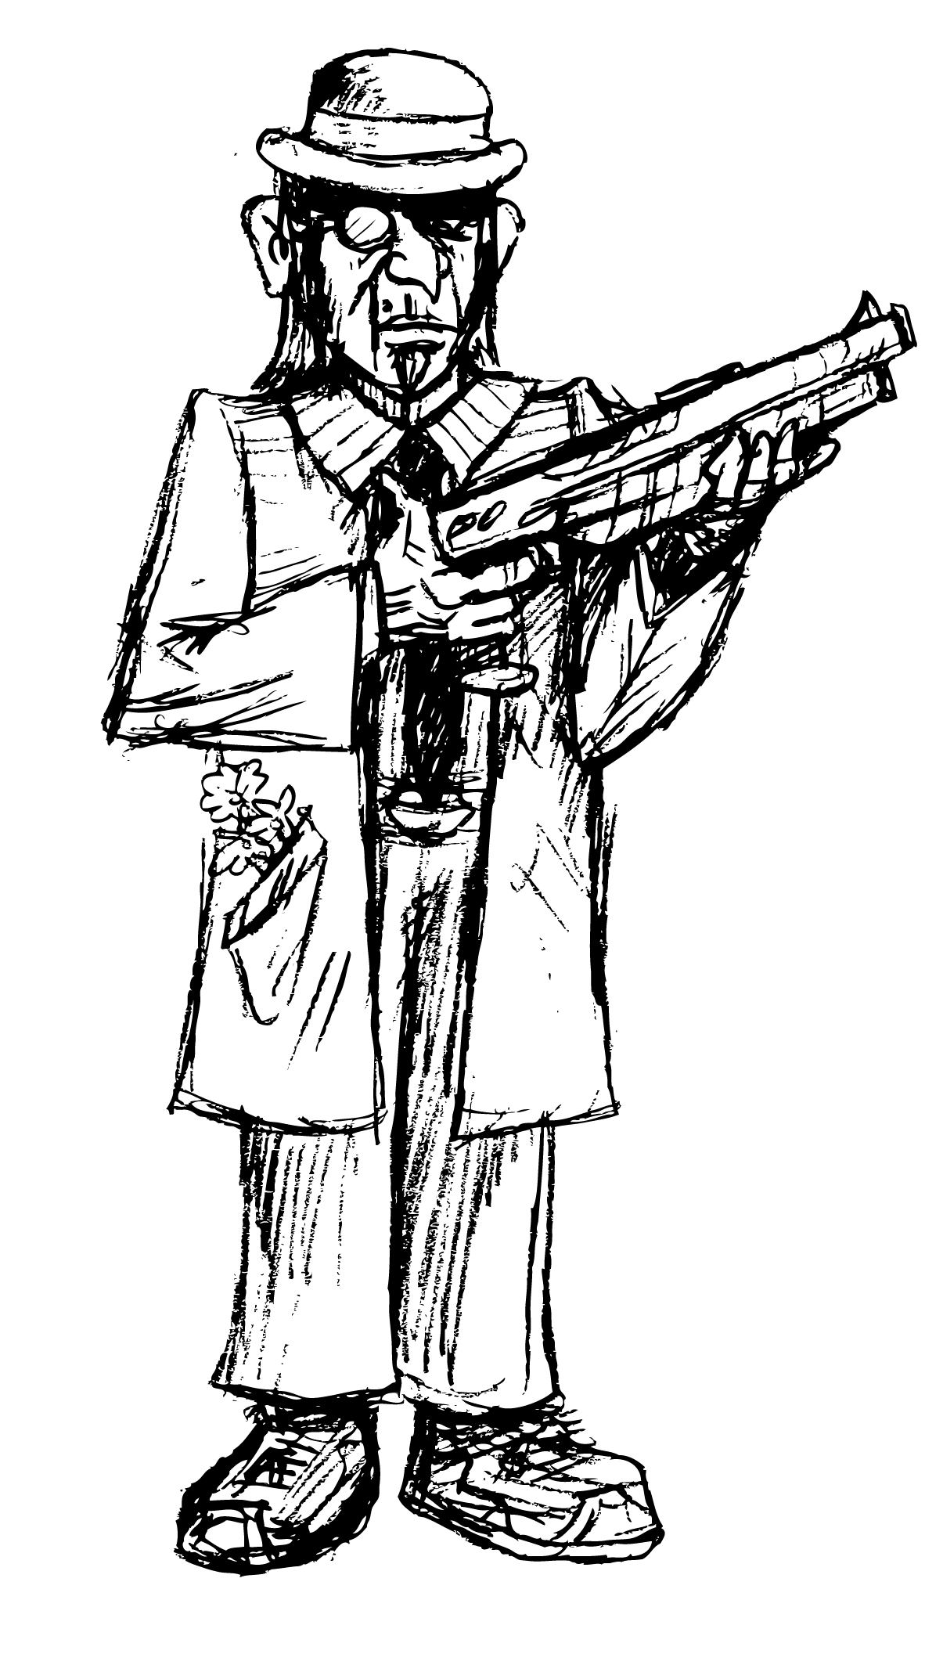
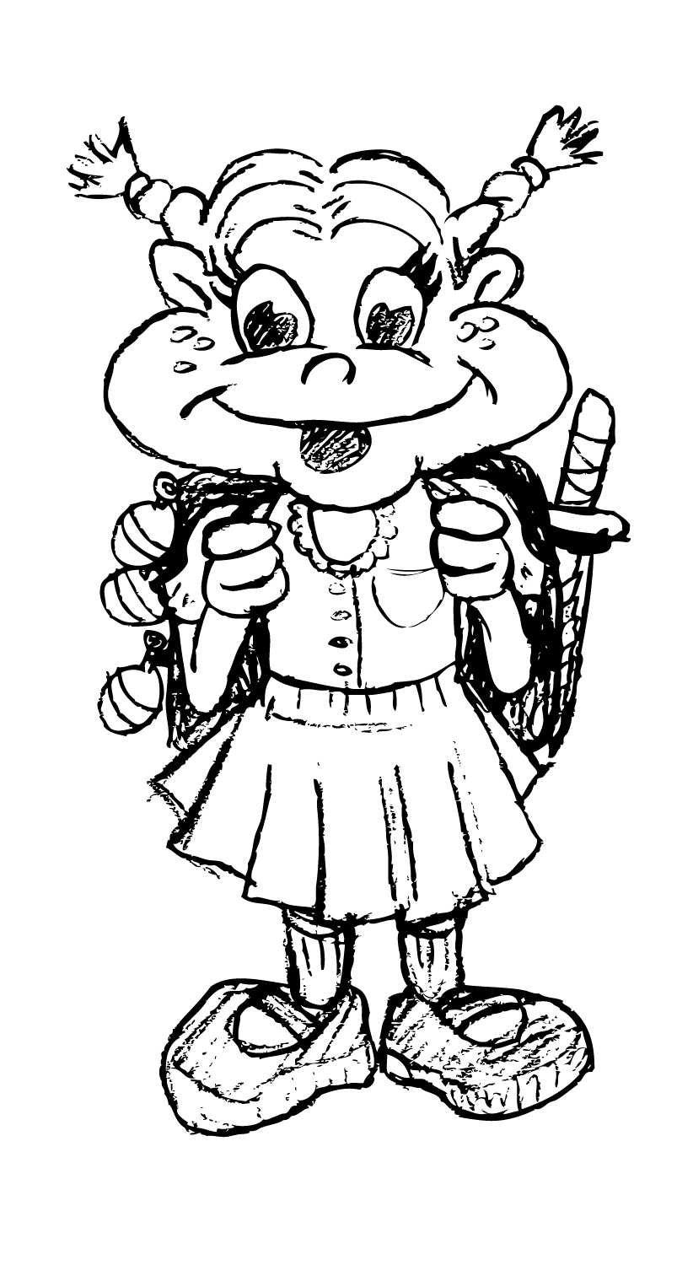

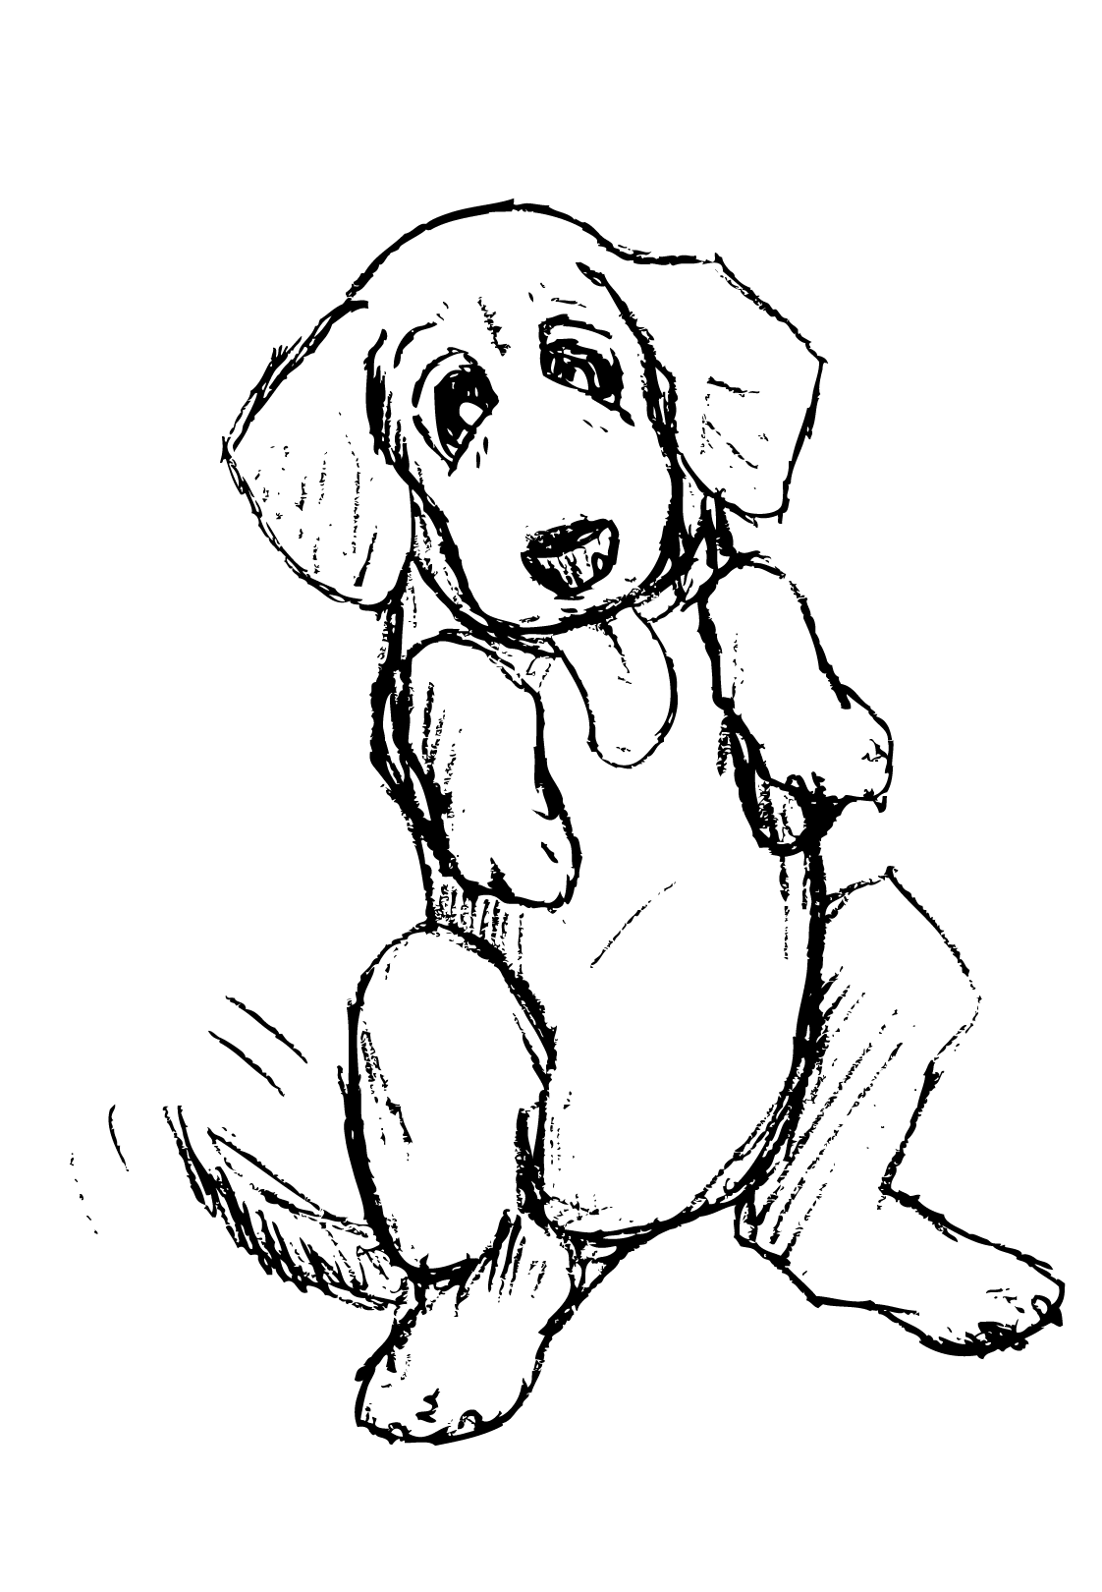
Lawrence and Lily:
Quest for the Kibble

Table of Contents
- Section I - Game Overview
  - Game Concept
  - Genre
  - Target Audience
  - Game Flow Summary
  - Look and Feel
    - Similar Titles
  - MetaData – A summary of the scope of the game.
    - Number of Locations
    - Number of Levels
    - Number of Characters
    - Number of Bosses
    - Number of Items
- Section II – Story, Setting and Character
  - Story and Narrative -
    - Setting
    - Storyline
    - Endings
  - Characters: Back story, personality, look, and abilities.
    - Lily E. Delfia
    - Lawrence Fishbone
    - The dog
    - Felix the Cat
    - Betsy Shocker
    - Oceanroll
    - Memory Mummy
- Section III – Objective, Flow, Difficulty
  - Objective
    - Main Objective
    - Level 1-Backyard
    - Level 2-Garage
    - Level 3-Kitchen
    - Level 4-Lily’s Bedroom
    - Level 5-Grandpa Lawrence’s Den
    - Level 6-Basement
  - Play Flow – How does the game flow for the game player
  - Difficulty

- Section IV Mechanics and Rules
    - General Details
    - Character-Swap System (CSS)
    - Specific Character Item Use
    - General Rules and Objectives
    - Purpose
    - Win Conditions
    - Loss Conditions
- Section V – Levels:
  - Level Design Details
  - Level #1
    - Purpose
    - New Required Skills
    - Item obtained during level/item use
    - General Details and challenges
    - Boss Details
  - Level #2
    - Purpose
    - Item obtained during level/item use
    - General Details and challenges
    - Boss Details
  - Level #3
    - Purpose
    - Item obtained during level/item use
    - General Details and challenges
    - Boss Details
  - Level #4
    - Purpose
    - Item obtained during level/item use
    - General Details and challenges
    - Boss Details
  - Level #5
    - Purpose
    - Item obtained during level/item use
    - General Details and challenges
    - Boss Details
  - Level #6
    - Purpose
    - Item obtained during level/item use
    - General Details and challenges
    - Boss Details

- Section VI – Controls and Interface
  - Controls Type
  - Button Layout
  - Menu
  - In-Game Heads-up Display (HUD)
- Section VII - Artificial Intelligence
  - Enemy AI – Villains and Monsters

- Section VIII – Technical
  - Target Hardware
- Section IX – Game Art
  - Concept Art
  - Characters
    - Lily
    - Lawrence
  - Levels
    - Level 1
    - Level 2
    - Level 3
    - Level 4
    - Level 5
    - Level 6
- Section X - Sound/ Soundtrack and Music
10.1 Sound Style
10.2 Interesting Soundtrack Details
10.3 Sound Effects

Section I: Game Overview

Section I - Game Overview
  - Game Concept
  - Genre: 2D, Single Player, Action, Puzzle-Platformer
  - Target Audience: Adolescents to young adults.
  - Game Flow Summary: The game flow is linear. Players will know what actions to take in order to advance to the next level. At each level players will find a new ability/weapon that will be used to defeat the boss and clear the level.
  - Look and Feel: The look and feel of this game is that of an action puzzle platformer. The interesting part is that the levels are seen through the perspectives of two stark different personalities. Half of the game is full of bright colors and has a carefree feeling. The other is darker, less interested in the outside world. Some examples of similar titles are below.
    - Similar Titles:
Castlevania: Portrait of Ruin
Takes the 2-character mechanic of this game and runs with it. However, the character swap system will be much more integral to gameplay, including more in-depth puzzles and enemies that require strategic use of both characters.

A Boy and His Blob
Similar cartoony style of puzzle-platforming and ability to use lots of different abilities to progress. Two characters, however, will allow for a greater variety of abilities and gameplay options, each distinctly matched to the individual characters’ personality and perception of the environment.

Lost Vikings
Both characters will have their own unique abilities required to solve puzzles and traverse the levels. In the proposed game, the characters will each gain new abilities throughout the adventure to aid them along the way. One other difference is that there will only be one character on the screen at a time, and they both always occupy the same space when swapped.

  - MetaData – A summary of the scope of the game.
    - Number of Locations: 1
    - Number of Levels: 6
    - Number of Characters: 2
    - Number of Bosses: 6
    - Number of Items: 10

Section II: Story & Setting

2.1.1. Setting
The story takes place in and around the Delfia household, presumably owned by Lily’s parents. However, like Lawrence’s wife, direct mention to the parents is never made. Most players will interpret the house as simply belonging to the parents and leave it at that, but to the more introspective other possibilities are open. Is this Lawrence’s retirement condo, and is Lily simply there spending time with him before his passing? Did Lily’s parents recently die in an automobile accident, and Lawrence has moved in to take care of her? Could this explain Lily’s timidity around cars? Or is the whole situation just a construct of Lily’s wild imagination? It could be any one of these, or it could be that the parents are just at work and the pair is biding their time until they return in the evening for dinner. It is important that the details of the home be left open for the sake of the player who wishes to find greater meaning/entertain greater curiosity in and about the game.

That said, there are at least six well defined regions of the home, which become the settings for the six levels of the game. Presented in the order they will appear in game.

- The Backyard- To Lily a magical forest, to Lawrence a ghastly jungle filled with recollections of Vietcong or Japanese spider holes or what have you. The first area the pair will experience together
- The Garage- To Lily a macabre carnival, due to her fear and lack of knowledge of automobiles, to Lawrence a comfortable area for exploration and showing his prowess, he has always been mechanically inclined and is all too ready to help Lily overcome her phobia of automobiles.
- The Kitchen- To Lily an overly plasticized kitchen, due to her only culinary knowledge being that of an EasyBake Oven. To Lawrence a waking nightmare, due to his antiquated sexist nature, he feels out of place in the kitchen. It might be inferred that the kitchen gives him painful memories of his deceased wife.
- Lily’s room- Lily’s place to shine, filled to the brim with stuffed animals, flowers, and everything cute. Lawrence, still shaken from his experience in the kitchen, has a bit of a breakdown here and decides the toys need to stage a coup against the tyrannical rocking horse. Here Lily will be allowed to shine and come to her grandpa’s aid preparing him for the ordeal in the den.
- Lawrence’s den- Lily has never before been allowed in the den, so to her this is an adventure! She sees it much like we might see an episode of Indiana Jones, her jump rope becoming her bull whip as she swings across imaginary pits and dodges dangerous mummies and the like. Here Lawrence must come face to face with all the mementos and tokens from his past, maybe a few that he has previously shut out of his mind. As seen through Lawrence, this room will give the closest possible representation of reality, for here he will confront his memories as they really were. This room will give the pair the strength they need to finish their journey.
- The basement- Lily, like any sane child, has her reservations about going in the basement. She shows remarkable resolve and courage for a girl her age, and accompanied by her favorite person in the world she steels herself for the ordeal. Here is where the pair will come face to face with the dog. Or will they?

2.1.2. Storyline
The game opens with Lily yelling for her grandpa. He rushes in to see what is wrong and is dismayed to learn that her excitement is just over the dog, who she remembers will need to be fed. Lawrence expresses his general distaste towards animals, but at least she didn’t disturb him about the cat, which he absolutely hates! Lily asks him to go to the backyard where she thinks she left his bowl. When the pair arrive they realize that is in fact not there, and that they have locked themselves out of the house. Level 1 commences. The pair find a key that that will let them into the garage. As they approach the sandbox Lily sees a water noodle come to life, which they must fight to gain entrance to the garage. Lawrence sees this as a giant anaconda, which must be disposed of to secure the LZ for his regiment. After defeating the noodle, the pair enter the garage.

Lily hesitates and we learn of her fear of cars. Lawrence is quick to assure her that everything will be fine while scolding her for her childish fears. Level 2 commences. Here they find the stepstool that will be necessary for them to reach up to the food in the kitchen. Neither of them is fond of Felix, the neighborhood cat, which has made his home in the garage. Lily sees Felix as the center ring attraction of the carnival, a giant tiger that she must keep at bay with the stepstool. Lawrence sees this as an opportunity to get back at the animal that has harassed him in the past, and has to chase it in and out of cars to capture and dispose of it. Once Felix is dealt with the pair move into the kitchen.

Lily feels at home as they reenter the house proper and begins gallivanting about the kitchen as Lawrence makes some inappropriate commentary on how this is a woman’s place, not his. Commence level 3. The stepstool comes in handy, as they are both of diminutive stature; with teamwork they use it to get to the cupboard where the dog food is kept. Lily hears noise by the oven and decides it needs to be checked out before they move on. She sees a cookbook on the counter and when they approach it, it flips open and out pops Betsy Shocker herself! Betsy makes fun of Lily’s childish cooking attempts, while scolding Lawrence for his neglect of the art of cooking. Lawrence is obviously disturbed by this apparition, possibly reliving memories of his wife. Once the ghostly Crocker has been dealt with, Lawrence is shaken. Lily thinks of the most comforting place she knows, her room, and drags him there for recovery.

Lily’s room has the opposite effect on him that she intended. Surrounded by all the cuteness in the room Lawrence feels that he is being kept hostage in some crazy POW camp. He decides to lead a toy uprising against the rocking horse, which he feels to be responsible for his current circumstances. Commence level 4. Lily sees the vigor her grandpa now has, and not understanding its cause feels that she has succeeded in getting him feeling better. She goes along with his revolution, not understanding its goal. They lead the toy army against the horse, who turns out to be the one that locked them out of the house in the first place. Lily is shocked by this betrayal by one of her most trusted toys, and convinces Lawrence to simply tame the horse instead of destroying it. They use her jump rope as a make shift lasso to control the horse, and once it is under control Lawrence applauds Lily for her newfound strength and decides its time to see his den. They bring the newly tamed horse along not knowing if it will be needed.

In the den Lily has the time of her life, finally getting to see the relics of her grandpas past. She immediately begins pretending to be an explorer wading through his past as if it were an ancient tomb filled with mummies and danger and excitement. Lawrence is ready to confront his memories here with the help of his overeager granddaughter. Commence level 5. The pair are on a search for the bowl, which they will need to give the dog his food. The pictures of Lawrence’s travels provide Lily the backdrop for her imagination adventure, while bringing up ghosts of the past for Lawrence himself. As they near the bowl, Lawrence feels that they are being followed. Indeed they are, as a mummy representing all the people Lawrence has lost over the years confronts them. Together, they fight and defeat the mummy, and Lawrence comes to peace with his loss, learning that all those he lost have shaped him into the caring and amazing grandfather that he is. With his newfound strength, and renewed love and appreciation for Lily, he accompanies her into the basement to finish their quest.
Armed with the all-powerful bowl the two of them venture into the dark recesses of the basement. Like most children Lily is a bit afraid of the dark and the noises the radiator is making. What started as a simple job to feed the dog has turned into a journey requiring the both of them to face their fears, and Lily is prepared to do so. In the basement they use the bowl as magic headgear to transform them into more powerful versions of themselves. When Lily dons it it takes the form of a crown and she becomes a princess, when Lawrence puts it on it serves as a helmet and he transforms into a young soldier version of himself. After shutting of the radiator and turning on all the lights they find the dog. At long last they think they are done, but the dog decides to attack them. It has been hungry for so long it is mad and tries to get back at them. Using all the skills and items they have acquired they are able to calm the dog and give him his food. Success! The game ends on a scene of the dog hungrily scarfing down his food as Lawrence and Lily pat him on the back.

2.1.3 Endings
Defeat- If a player is defeated on a certain level they will hear a dog whimper as if hungry, and be greeted with a screen asking if they wish to continue.

Victory- When the dog has been fed successfully, the final cutscene will play with the three together, credits roll.

2.2 Characters

2.2.1 Lily E Delfia- The jubilant young protagonist. Lily is largely the product of her own imagination. Real events seem to not have much impact on her, she prefers her own interpretation of things to what reality may be. Her biggest connection to the real world is her grandpa, hero, and role model Lawrence. She is unaffected by her grandpa’s cynicism and takes it upon herself to try and make him smile, though she is rarely successful. Lily is affected by obvious separation anxiety, further agitated by the fact that her parents are never seen or heard of in the course of the game. Lily has the habit of anthropomorphizing everything she comes in contact with; all her toys have names and relationships with her. This lends to her being able to talk to things in the environment and gather information when it would otherwise be unattainable. Lily is inseparable from her jump rope, which is one of her main tools for progressing through the levels. Lily is a very fragile girl, afraid of many different things, which may be why she has such a powerful imagination to help her cope. As she progresses in the game she faces many of her fears and learns to put them in their place. Her love her grandpa is closely followed by her love for her dog, so it is her that drives the pair on their quest to take care of the animal.

2.2.2. Lawrence Fishbone- The maternal grandfather of Lily, the games second hero. Due to osteoporosis he is about the same height as Lily. Lawrence’s past greatly shapes his motivation in the game. He is a war veteran, although of which war (even more importantly, for which side), is left to the player’s speculation. It is to be assumed that Lawrence is a widower although no direct reference is ever made to the departed. His ordeals in war and consuming loss in personal life have led to the development of a jaded, dark personality. Old age has affected his recollection so many of his prejudices are misdirected, due to a growing dementia. He feels he has seen it all, which makes him very critical of Lily’s juvenile explanations of their surroundings. He sees things his way, and scolds Lily for her inability to do the same. A product of a different era, Lawrence sees the world as classic noir, which is what the player will see when controlling Lawrence. Although his personality is in stark contrast to Lily’s, she is the object of his adoration; as such he generally ends up giving into her desires, as reluctant as he may appear at first. Capable of much love, Lily is his only humanizing connection, and he secretly longs to show her how much he cares. He’ll never say it, but he does get satisfaction out of their time together. He begins the quest simply following along with Lily’s impulses, but he evolves into a willing participant near the end when the pair visit his den. Certain breakthroughs give him a certain willingness to see their journey to the end.

2.2.3 The dog- Never referred to by name, the dog is the end goal of the game. Not naming him allows players to substitute their own name, thus feeling more connected to the story. Lily often refers to the dog as the loving “my puppy” and Lawrence shows his indifference by simply calling it “dog”. The dog will not make an appearance until the very last level, but it will be heavily referred to as a driving point for the plot. Dog breed is still undecided, but it should probably be something small.

2.2.4. Felix the Cat- A nuisance to Lawrence and Lily both, first showing himself in the backyard level as the one that stole the key to the garage. A neighborhood cat that has taken residence in the family’s garage, constantly making noises and scaring Lily. Lawrence hates it for his own reasons. Felix is the boss at the end of the garage level.

2.2.5. Betsy Shocker- Boss of the kitchen level. Betsy is very arrogant of her cooking abilities and makes Lily feel bad, while shaming Lawrence for his neglect of cooking. This could be interpreted as his lack of taking responsibility in his marriage, the confrontation with Betsy affects Lawrence greatly.

2.2.6. Oceanroll- Lily’s rocking horse. Boss of the bedroom level. Lawrence blames Oceanroll for many of his problems, and stages a coup for control of the room. Oceanroll is important because Lily feels empowered and confident while riding him. After the battle, Oceanroll joins the two and becomes a tool for helping them further their quest.

2.2.7. Memory Mummy- the incarnation of Lawrence’s past. Boss of the Den level. Lily stirs up the mummy by running rampant in the den and asking too many probing questions about Lawrence’s past. The confrontation ends up beneficial for him, and the mummy is not seen again after being dealt with.

Section III: Objectives/Flow/Difficulty

3.1. Objectives: Clear all levels with Lily and Lawrence on their adventure through the house to the kibble.

3.1.1. Main Objective-Get the dog his food! Accomplished by progressing through each subsequent level.
Level Objectives
3.1.2. Level 1 Obtain the key from Felix so you can enter the garage and subsequently the house.
3.1.3. Level 2 Grab the stepstool on the way inside so you can reach up into the cupboard to get the dog food out of the kitchen.
3.1.4. Level 3 Get the dog food ready. (also necessary to use to distract certain enemies that will be encountered).
3.1.5. Level 4 Escape the bedroom; tame Oceanroll so Lily has the courage and strength to help Lawrence in his den.
3.1.6. Level 5 Confront Lawrence’s past, get the dog bowl so the dog has something to eat out of.
3.1.7. Level 6 Find and feed the dog at all costs!

3.2 Flow
The game will be very linear, there will never be a question as to what the player needs to do next, but the how and the why may be unclear at times. Players will be ushered into the next level through a cutscene after successfully completing the previous one, but through a main menu will be able to access prior levels they would like to replay. Progression will be very dependent on the item that is obtained in every level. For example, you won’t be able to beat the boss in the garage without the stepstool. This item mechanic will work very similarly as it does in the Legend Of Zelda series. The new item will be obtained about midway through the level, and will be necessary to progress through the remainder of the level, and instrumental in the boss fight. This item will continue to have great importance in the first half of the subsequent level, until the next item is found, and this new item takes center stage. The process will repeat with each new item found, with older ones still useful but constantly less integral. The basement level and the final boss fight will require implementation of all the items and techniques the player has discovered. Change between Lily and Lawrence will be required at multiple points in each level and each boss fight, but will happen at the player’s will.

3.3 Difficulty
The levels will be pretty equal on the difficulty spectrum with the exception of the backyard, which serves as a bit of a training ground, and the basement, which is the proving ground of everything, the player has learned. There will not be different difficulty levels as I feel that takes away from the experience of the game. Enemies will react and be just as difficult for all players, and this allows for more focus to be put on the puzzles than the combat. Each level will be very different and have different tricks required to complete it, but this does not necessarily mean one needs to be harder than the next, just different.

Section IV: Mechanics and Rules

4.1.1. General details: For the most part, gameplay rules and mechanics are traditional and conform to what players and designers have come to expect from 2D platforming games. For example, colliding with enemies or dangerous environmental elements causes damage to the character, falling down pits causes instant death, jumping on certain enemies destroys them, losing all lives results in “Game Over,“ etc. However, the following mechanics are either unique to this game or are not particularly common in the genre.

4.1.2. Character-Swap System (CSS): The most defining features of this game are based around the two unique playable characters, Lawrence and Lily, and the ability to swap play between them in real-time at the press of either L2 or R2.

- Upon swapping, the entire visual display changes style to match the perception and personality of the currently controlled character.

- The characters swap exact position and location as well, along with any momentum (mid-air or grounded). This allows for interesting platforming and puzzle challenges, as both characters’ various abilities must be alternately used with quick reflexes and finesse in order to complete the tasks at hand. For example, near the end of the first stage Lily must first jump off a ledge, then use her Jump Rope to latch onto a broken swing-set, then swing herself across the ensuing gap. Unfortunately, even after swinging with the Jump Rope, the next ledge is barely too far away. Thus, in mid-air, the player must swap Lily for Lawrence and, before plummeting to certain doom, use his Cane to grab the ledge above and pull himself (the duo) to safety.

- In addition, all enemies and environmental elements have unique looks and behaviors for each character and change in real-time as well. For example, a wall of dangerous thorns for Lawrence might be a mass of tangled flowers and vines for Lily, which can then be climbed to advance to the next area. Further, an annoying housecat that is relatively harmless (but still a nuisance) for Lawrence might be a dangerous jungle predator that tries to eat Lily. Players must decipher these various environment and enemy behaviors, then use them to their advantage by character-swapping at the appropriate moments and using the correct abilities in tandem.

4.1.3. Specific character item use: For each new usable artifact that the player collects, each character has a unique method of using that item. These unique uses are integral to defeating enemies, solving puzzles, and locating secrets. For example, once the step stool is acquired, Lawrence can use it (as one would expect) to climb up and reach higher areas. Lily, however, uses the step stool as a lion-tamer in a circus does, holding it horizontally to keep dangerous enemies at bay.

4.1.4. General rules and objectives: Only one character can be used at a time. Objective is to obtain needed item in level and use item to defeat boss and progress onto the next level.

4.1.5. Purpose: Progress through the game by completing each stage and each level. Challenges such as puzzles, enemy encounters, and environmental hazards will try player skill and patience, but persistence, learning from mistakes, and developing the necessary reflexes will eventually lead to success. Do everything necessary to eventually complete the ultimate goal: feed the dog!

4.1.6. Win conditions:
- Each level: Reach the end of the level by completing all necessary puzzles, defeating all necessary enemies, surviving all necessary platforming areas, and conquering the level boss without dying. Additionally, the new item must be found and used on each level in order to progress through particular required challenges.

- Entire game: Complete all the levels, defeat the final boss, and ultimately use your amassed abilities to feed the dog. It’s that simple!

4.1.7. Loss conditions:
- Each level: 1) Die. This can be accomplished (not that it’s an “accomplishment,” per se) by the player either losing all life from enemy or environmental damage or by falling down bottomless pits in platforming challenges. Each time the player dies, the number of remaining lives decreases by one, and the player must restart from a designated checkpoint. If the player dies with no remaining lives, the “Game Over” message is displayed, and all progress made on the current stage is lost. The player must retry the stage from its beginning, re-completing any previously conquered challenges on that stage. 2) Run out of time. This can only occur during timed challenges. If the timer runs out before the player has completed the required challenge, it is as if the player died. The same rules for losing lives and potential “Game Over” are followed.

- Entire game: To conform to modern gaming expectations, reduce overall player frustration, and put the barrier of entry for new players as low as reasonably possible, there is no real loss condition for the game in its entirety. Progress is recorded and saved as stages and levels are completed, and there is no limit to the number of times players can continue after receiving “Game Over.” Basically, as long as the player does not give up, there is no way to lose the game and have to restart the entire experience from the beginning.
Section V: Level Design and Maps

5.1 Overarching level design details:
- Since each level will feature distinct presentation styles and unique character, enemy, and environment interactions for both Lawrence and Lily, we will give a detailed description of the various facets of each individual level. In addition to the presentation (though artistic details for each will be covered more in-depth in the Aesthetics, Art Style, and Direction section) and mechanics of the levels, we will include a few examples of the platforming and puzzle challenges that players will have to overcome in order to obtain victory. That’s right, VICTORY!

- Being that the game is a 2D puzzle-platformer (with enough action to keep things interesting, of course), level designs and layouts will take cues from other games in similar genres, such as A Boy and His Blob, Braid, and The Lost Vikings (with perhaps a hint of Super Mario Bros.).

- Levels (and their sub-stages—discussed in the next paragraph) will be accessible via a world map, similar to the world maps in recent Super Mario games. This will allow the player to see a visual representation of the entire game world and how each level relates to the others. Further, it allows the player to replay previously completed levels with the new powers and upgrades that are found later. Extra secrets and challenges (not to mention rewards!) await those who take advantage of this feature and re-explore earlier stages with abilities acquired later in the game.

- Each level will be divided into two or three unique stages. The first of the stages in each level will end with some sort of mini-boss or over-par challenge. The last of the stages in each world will conclude with a boss battle that requires the use of any new items acquired in the level and any additional skills developed along the difficulty curve to that point. As expected, difficulty and challenge in both puzzles and action segments will evenly increase as the player progresses toward the end of each stage, level, and eventually the entire game.

- The location, exact measurements, and placement of each character, enemy, and environmental object will remain constant as the world changes from Lawrence’s perspective and gameplay to Lily’s, and vice-versa. The art style, behaviors, and potential interactions of all of the above, however, will change in real-time based on which character is currently in action. This is arguably the most fundamental mechanic for the puzzle solving, platforming, and combat in each level.

5.2. Level 1: Backyard (clever names for each level will be chosen during development)

5.2.1. Purpose: Obligatory tutorial level; used to teach fundamental mechanics of the game, such as jumping, basic attacking, character-specific ability use, and the imperative character swapping.

5.2.2. New required skills:
- Both Characters: Run, jump, basic attack, character-swap

- Lawrence: Cane swat, ledge grab (with Cane)

- Lily: Jump Rope swipe, Jump Rope attach/swing

- Character-swap techniques (Example: Jump or swing with Lily, character-swap in mid-air, ledge grab with Lawrence, then pull up onto the platform to safety)

5.2.3. Item obtained during level/item use: Key
- Lawrence: Uses Key to open obviously “locked” objects (doors, chests, shutters, etc.) with visible keyholes or other cues that suggest using the Key. Upon using the Key, an unlock mini-game/puzzle will commence that the player must complete to actually get the object open.

- Lily: Uses the Key as a sort of divining rod to detect invisible secrets, including secret areas or alternate worlds of imagination (basically bonus rooms or bonus sequences). These entrances are not always obvious, and they are not necessarily marked by consistent visual cues (like keyholes). It will take exploration and occasional trial and error to locate the places where Lily can use her version of the Key.

5.2.4. General details and challenges: This level will be focused primarily on simple platforming and basic combat as a means to familiarize the player with the general game mechanics and style. The beach-jungle-backyard theme has a wide variety of interactive elements, including swing sets for crossing gaps and reaching high places, fox holes for avoiding enemies, and water that can be a hindrance in progression until surpassed with a bit of puzzle solving.

An example of the possible challenges takes the form of a stretch of beach littered with landmines (Lawrence) or beach toys (Lily). Lawrence must be able to use his Cane to grab rocky ledges above and climb over them, but the landmines are invisible beneath the sand. Thus, it is dangerous to traverse the beach as Lawrence. However, the player can use Lily’s Key ability to see what she perceives to be beach toys buried under the sand. Using this ability, the player can safely avoid the toys (which could still hurt the bottom of Lily’s tender feet). After reaching the ledges safely, the player can then character-swap to Lawrence to use his Cane for ledge grabbing.

5.2.5. Boss Details: Anaconda/Living water noodle
This boss fight consists of Lawrence’s anaconda and Lily’s anthropomorphic water noodle. The fight takes place with the characters on a precarious platform over a murky kiddie pool. The snake/noodle swims beneath the surface, bubbling and foaming the water until it becomes virtually invisible while in the water. The enemy then leap-attacks from the water at the unsuspecting heroes. In order to avoid these assaults, Lily must use her Key ability to discover the noodle’s location, and then whip her Jump Rope at it to pull it to the surface. Finally, Lawrence must be swapped in, and then use his Cane to actually deal damage to the foe. Upon running through this attack pattern a number of times, the boss will be defeated, and the door to the next level, the Garage, can be accessed and unlocked using Lawrence’s Key ability.

5.3. Level 2: Garage

5.3.1. Purpose: New grounds for refining basic skills and learning how to more effectively character-swap for puzzle, platforming, and action segments.

5.3.2. Item obtained during level/item use: Step Stool
- Lawrence: Uses the Step Stool as one is naturally inclined to use a step stool. He sets it where he is and climbs on top of it to gain access to previously unreachable areas.

- Lily: Uses the Step Stool, as would a classic circus lion tamer, to keep dangerous enemies at bay.

5.3.3. General details and challenges: Based on a circus theme, the Garage level contains a large amount of tricky traps, high-flying platforming, and enemies. From flaming loops to high wires to creepy clowns, Lawrence and Lily will have to push their skills to the test to overcome this crazy carnival’s attractions.

A challenge example in this level consists of a gang of clowns attacking the heroes, though a high wire escape route looms far overhead. The player must use Lily’s Step Stool ability to herd them into a corner without taking any damage from pies to the face. Once the clowns are out of the way, the player has enough time to then use Lawrence’s Step Stool ability for extra elevation. Next, from this new height, the player must swap to Lily, and then quickly use her Jump Rope to attach to the high wire above. Finally, a swing to safety from the high wire completes the challenge.

5.3.4. Boss Details: The Cat named Felix / Circus tiger
This boss fight is an amalgam of Felix (the housecat that Lawrence detests) and Lily’s perception of Felix as a circus tiger. Taking place in the center ring of the big top with a clown car in the middle, the heroes must navigate typical circus obstacles while defeating Felix. One central mechanic for defeating Felix requires Lily to use her Step Stool ability to force Felix’s tiger form into the clown car through a window. With Felix confined in the vehicle, Lawrence must then attack Felix’s housecat form as it tries to escape through the various gaps and slot openings (windows, wheel wells, etc.) in the car. This plays out much like a wac-a-mole type of mini-game. If the player can successfully manage this and other techniques (including dodging clowns, jugglers, and trapeze artists), the door to the next level, the Kitchen, will finally be revealed.

5.4. Level 3: Kitchen

5.4.1. Purpose: Level to finally begin offering some challenge to more seasoned gamers. Makes sure that players are no longer advancing by pure chance or button-mashing. Still beatable by newer gamers as long as they’ve developed skill and reflex through the earlier levels.

5.4.2. Item obtained during level/item use: Kibble
- Lawrence: Uses Kibble bits as if they were rocks or, if the item button is held, grenades. When used as rocks, the Kibble can distract or stun enemies, trip far-away switches, or set off other physics-based events. As grenades, the Kibble can be used to deal damage from a distance, but precise timing is required.

- Lily: Uses Kibble bits to lure out and gain control of creatures located throughout the levels. Once fed, most friendly creatures will perform scripted actions, but the occasional creature must be actively controlled by player commands.

5.4.3. General details and challenges: The Kitchen is both strangely cute and scary. A nightmarish obstacle course of blades and steam-powered machines for Lawrence, the Kitchen houses many instant-death dangers. For Lily, however, the environment takes on a creepily childlike façade, presenting itself as a personal toy kitchen popular in past decades. Challenges revolve around the use of Kibble to deal with friend (roaches) and foe (appliances), as well as the avoidance of all manner of cutlery.

5.4.4. Boss Details: Betsy Shocker
Yes, this universally loved maker of all things delicious emerges from a nearby cookbook and becomes a disgusting enemy when seen through both Lawrence’s and Lily’s eyes. To Lawrence, she is stepping beyond her bounds as she tries to teach him to be useful in the kitchen. To Lily, Betsy is only around to try to capture the last ingredient for her secret recipe: children. Again, using the Kibble (BOOM) and other abilities, Lawrence and Lily must defeat Ms. Shocker to continue on their Quest for the Kibble (hey, that’s the name of the game!).

5.5. Level 4: Lily’s Bedroom

5.5.1. Purpose: Level to more seamlessly integrate all previously acquired abilities into action and platforming segments. Players will need quick reflexes and the skill to imagine new, interesting patterns and combinations of abilities to succeed.

5.5.2. Item obtained during level/item use: Oceanroll the Rocking Horse
- Lawrence: Uses Oceanroll as a mighty steed (though it’s roughly the same size that he is). Upon Oceanroll, Lawrence has much greater speed and can trample over minor enemies.

- Lily: Uses Oceanroll as a mystical Pegasus/unicorn. Upon Oceanroll, Lily has greater courage, can travel somewhat faster, and can leap significantly higher than usual due to the extra help from Oceanroll’s Pegasus wings.

5.5.3. General details and challenges: Viewed as either a thriving zoo of living stuffed animals (Lily) or as an oppressive POW camp (Lawrence), the heroes must navigate unexpected dangers in Lily’s Bedroom to set free the captives. The mini-boss in Lily’s Bedroom is Oceanroll, Lily’s Rocking Horse. Upon defeating Oceanroll, the player has access to using Oceanroll as an item. With the mighty (Rocking) Horse on the player’s side, courage abounds, and the player can continue fearlessly forward!

5.5.4. Boss Details: Speed and obstacle course
Though there is not a boss at the end of Lily’s Bedroom, there is a difficult speed and obstacle challenge that the player must navigate while riding Oceanroll. Imagine the hover-speeder and surfing stages from Battletoads (though not nearly as frustrating and with more variety of enemies and obstacles along the way). Upon completing the course in the allotted time, the path to Lawrence’s Den lies before the player.

5.6. Level 5: Lawrence’s Den

5.6.1. Purpose: Challenging level for veterans and newcomers, alike. Proficiency in riding Oceanroll at the correct times and effectively toggling between all available abilities becomes paramount.

5.6.2. Item obtained during level/item use: Dog Dish
- Lawrence: Uses the Dog Dish as a helmet that transforms him into the dashing young soldier he was in years gone by. Thus, for a limited time, he has access to “olde-tymey” firearms and increased speed and jumping ability.

- Lily: Uses the Dog Dish as a tiara that transforms her into a beautiful princess. For a limited time, Lily’s royal beauty mesmerizes minor enemies, stunning them and allowing her to pass by unscathed. Additionally, a small regiment of woodland critters flocks to her side to swarm-attack nearby foes.

5.6.3. General details and challenges: Lawrence’s Den is quite an experience for the pair. Reminiscent of pulp adventures like Indiana Jones or Athena Voltaire, the sepia tone invokes Lawrence’s own memories of long-past adventures. With horse chases, Nazis, and even demons sealed away by ancient civilizations, the Den will require split-second reflexes and the constant use of everything in the player’s arsenal.

5.6.4. Boss Details: Memory Mummy
Lawrence’s suppressed memories take shape in a dangerous Mummy, one that Lawrence must finally face to free himself from a troubled past. The Mummy commands many formidable supernatural powers and is quite difficult to defeat. However, by using the Dog Dish and gaining access to Lawrence and Lily’s ultimate powers, the player can manage to successfully avoid taking damage while still dealing enough damage to the Mummy to finally bring it down.

5.7. Level 6: Basement

5.7.1. Purpose: The ultimate L&L test. Requires mastery of all elements previously encountered in the game, while testing general reflexes and gameplay prowess by throwing in new types of challenges. Get ready!

5.7.2. Item obtained during level/item use: None
Though there’s nothing exactly new to obtain and use in this level, the player will need to find new and interesting ways to use any available abilities to overcome mind-bending challenges, the likes of which have yet to be seen!

5.7.3. General details and challenges: It’s a Basement. Basements are freaky. Lawrence and Lily see it this way, too. While Lawrence experiences the basement as a claustrophobic, run-down bunker, Lily imagines it full of scary living machines. The most frightening of these is the Furnace (think Home Alone). As the mini-boss, the Furnace has a sinister laugh, breathes fire, and summons all manner of cast-iron demons to destroy the heroes. Other challenges include lack of visibility in the darkness, all sorts of disgusting giant bugs, bottomless drainpipes, and a generally terrifying ambience.

5.7.4. Boss Details: The Dog
Despite the whole journey being based around helping this poor mutt, the Dog mutates into a frightening monster and attacks upon discovering the heroes in its lair. With multiple stages within this final boss fight alone, this truly is the ultimate test in the game. Using a combination of every ability acquired throughout the experience, the player will finally be able to show off every ounce of skill that s/he has developed over the course of Lawrence and Lily: Quest for the Kibble.

Section VI: Controls and Interface

6.1. Controller type: Being that the game will be available via the online download services of all the major console platforms, a traditional controller with several action buttons will be required. In the case of the PC version, keyboard commands can be set up, with the option of using a traditional-style controller peripheral.

6.2. Button Layout: Using the Playstation controller as a reference (other consoles’ controllers will use the same placement layout, though they have different labels for the individual buttons), the basic commands will be the following:

- Character movement: Left analog/control-stick

- Camera movement (minimal, used for viewing just a little bit more around the edges of the screen to help solve puzzles or locate secrets): Right analog/control-stick

- Jump: X

- Basic attack: Square

- Basic character ability: Circle

- Item use: Circle

- Item select: L1 and R1

- Character-swap: L2 or R2

- View pause menu: Start

- View world map: Select

- As players progress through the game, other skills and combo abilities will become accessible through specific, more complex button combinations

6.3. Menu: Traditional, clean menus will be used for navigation through the game’s title, options, start, and pause menu screens. Nothing of unusual note here, except the Easter egg of being able to swap the visual art presentation of these screens in real-time by hitting the character-swap button.

6.4. In-game heads-up display (HUD): The HUD will be minimal so as to intrude on the visual features of the detailed levels as little as possible. However, even the HUD presentation will change visually as characters are swapped in real-time. The HUD will feature the following:

- Character icon: A clean, simple graphic of the currently used character’s face. This icon will match the respective art style of the two characters. Further, the face will react with expressions in real-time to the event that is happening, be it collecting an item or pick-up, taking damage, completing a level, etc. The character icon will be located in the upper left corner of the screen, as is probably expected. Finally, the number of lives that the player has remaining will be displayed in a small x-digit format (i.e., x3) over the bottom of the character icon.

- Character life bar: The life bar, like all other visual elements in the game, has a unique look for both Lawrence and Lily. Though nice-looking, it’s not too flashy so that it does not draw undo visual weight to itself. It originates at the character icon and extends horizontally to the right, shrinking back to the left as damage is taken.

- Currently equipped item icon: The current item is visually represented just underneath the character icon. It shows a picture of the item that the player has selected with a unique visual twist for whichever of the two characters is currently in use. Further, it changes in real-time as different items are equipped using the item select commands.

- Boss/enemy life bar: As necessary, this life bar will appear at the upper right of the screen for major enemies or bosses that the player encounters. It appears as the encounter begins, then disappears when the encounter ends, either by the player defeating the enemy, the enemy defeating the player, or some other in-game event separates the player from the enemy (likely to cross paths again at a later time). As expected, the enemy icon and the enemy life bar have a different visual style for each player character.

- Timer display: Occasionally, players will come across challenges, puzzles, or battles that will require completion within a set amount of time (one of the oldest video game design tools to create suspense and anxiety, heh). Under such circumstances, the timer display of remaining minutes and seconds (perhaps just large numbers of seconds—no dedicated minutes display) appears in the upper middle of the screen. Even this simple display of decreasing numbers has a different appearance for both Lawrence and Lily. Further, as the counter reaches more and more dangerous (read: lower) numbers, its visual representation also changes to reflect the panic that the player should be feeling.

Section VII - Artificial Intelligence

7.1. Enemy AI – Villains and Monsters
- Each level will have its own specific set of enemies due to the stark contrasts in each level design, a common enemy type would be too reminiscent of prior levels taking away from the uniqueness of the new encounter. Each enemy unit will have two incarnations, one to be manifested while playing as Lily and the other while Laurence. One idea is an alley cat that is harmless while playing as Lily, yet transforms into a jungle cat that stalks Laurence and tries to catch him off guard. Also, an example in the kitchen level, the cutlery could be an enemy type. The knives could be plastic and toy-like while seen by Lily, but become razor sharp and aggressive when approached by Laurence.

Section VIII – Technical
8.1 Target Hardware
8.1.1. System Requirements/ Platform: XBOX Live Arcade, PlayStation Network, WiiWare, PC



Section IX: Game Art

9.1 Concept Art
Concept Art: Due to the nature of the game involving two characters with drastic differences the art styles also needed to be quite different. The art style for Lily perspective is vibrant, cheerful and imaginative. While, the Grandpa's perspective is that of a grumpy old man. He has a pessimist point of view and the art style will reflect that, very similar to an art noir style.

9.2 Characters
9.2.1. Lily: Character sketch of Lily, these sketches are preliminary and the sketch describes a young exuberant girl ready for adventure.
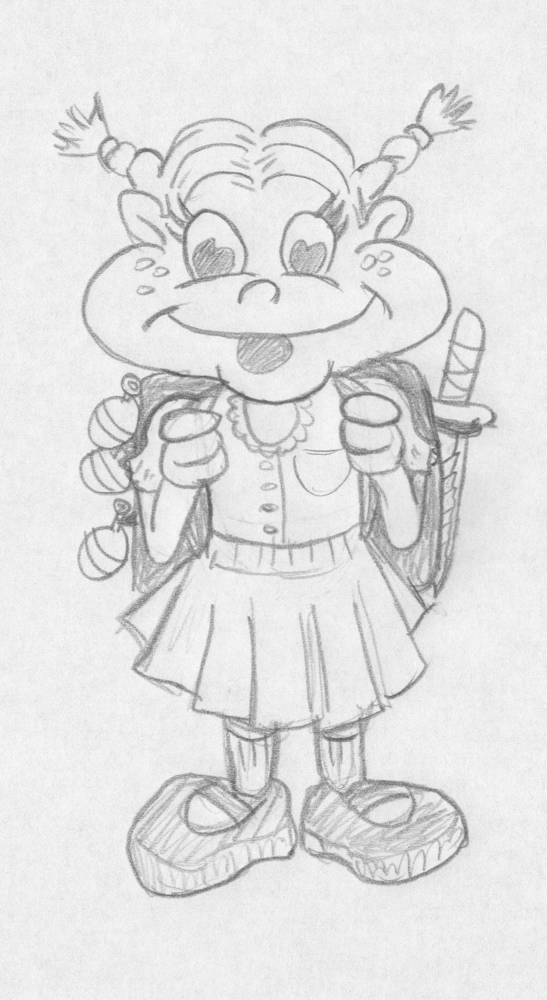

9.2.2. Grandpa Lawrence: Although Grandpa Lawrence is a war Veteran; he only carries such ammo in his own mind.
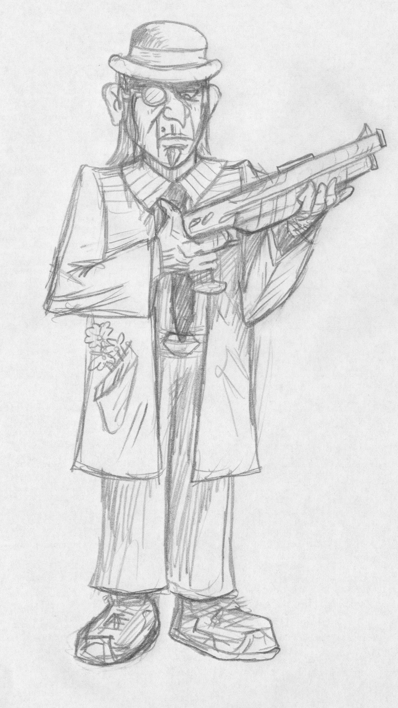

9.2.3. The Dog: The no-name dog has one thing on his mind, food.
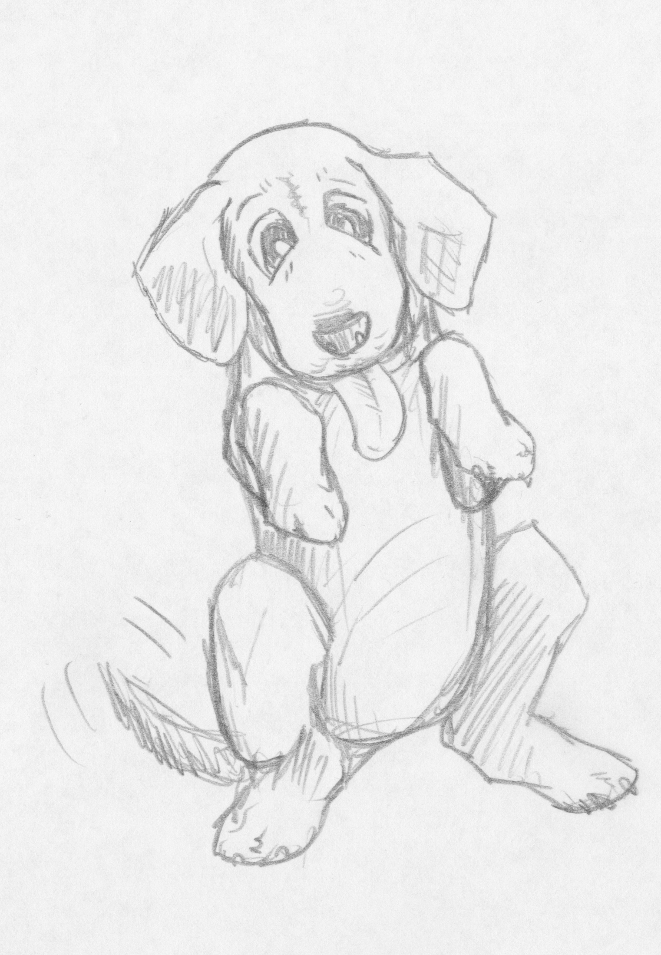

9.3 Levels / Environments: Environments: All the environments or levels will change with the changing of the character.
9.3.1. Level 1: Backyard Level: Both perspectives resemble a jungle/beach area. The backyard becomes a jungle and the sandbox turns into a beach.

Lily: In her jungle and beach the art style will be bright with lots of color. The jungle itself is going to be a tremendous. The jungle and beach are full of creatures that Lily can converse with. Backyard toys are scattered around and can be seen in the jungle covered over with vines and plants.

Grandpa Lawrence: His jungle does not have a safe and carefree feel. The jungle and beach are grim flashbacks of the war. The art is similar to Vietnam pictures and the backyard toys turn into mines that Lawrence must avoid.

9.3.2. Level 2: Garage Level: Circus Theme

Lily: The garage level has a circus theme. The circus that Lily sees is one that is experienced in ones childhood. Inside the circus tent everything is visually simulating. The color are bright, the characters are moving and performing acts.

Grandpa Lawrence: His circus is a more of circus of unnatural means. The art style for his circus is darker, the color scheme involves dark deep colors. There are many characters that are unnatural and are in the circus because they are strange.

Example:
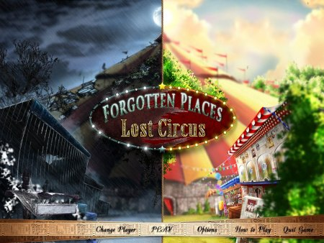
9.3.3. Level 3: Kitchen Level: “Betsy” comes to cook

Lily: The art style for this level is based around 50's style art. The kitchen, décor and clothing will reflect the 1950's era. An example is shown below. During this level Lily is enjoying her time in the kitchen with her Easy Bake Oven. She meets a character named Betsy Shocker, who is trying to cook Lily in her pie.

Grandpa Lawrence: Grandpa's kitchen adventure takes him to a third world country market place. There is a lot of bustling and hustling. There he meets a little rough around the edges Betsy, who wants to teach him how to cook. His worst nightmare. The art for the grandpa's perspective is brighter than other levels. It depicts a market place. There will be carts, tents, street performers, shops.

Example:
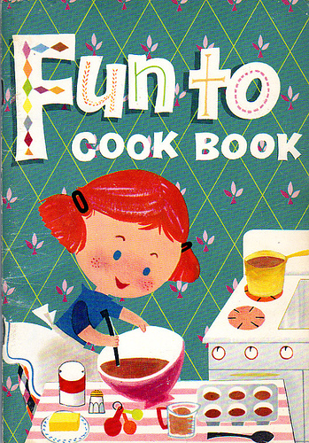

9.3.4. Level 4: Lily's Playroom

Lily: Lily's playroom is full of stuffed animals, dolls, and pink. The design of the level for Lily's perspective is that of a room packed full of animals, which turns into a zoo. The art style of the zoo animals is cartoon-like and looks like they are colored with a crayon.

Grandpa Lawrence: The animals that are prisoners take Lawrence to a POW camp. The art for this has a hint of anime and Japanese influence. Limited to only a couple colors, the camp is a dreary sight.

9.3.5. Level 5: Grandpa Lawrence’s Den: Grandpa's Den is a typical den with a desk and pictures and other memorabilia used as décor around the room. The carpet is brown, the desk is brown, and the walls are wooden panels.

Lily: The den becomes a desert wasteland and Lily is an archeologist finding grandpa's memorabilia. The art style for this level is similar to Indiana Jones: Raiders of the Lost Arc mixed with some Egyptian stylized art.

Grandpa Lawrence: The Den takes Lawrence down memory lane. The art has a photographic feeling. As if Lawrence has taken a trip inside the photos.

9.3.6. Level 6: Basement Level (Final Level) This level is the scary basement level. There is a staircase that leads down to the basement. The basement is not well lit and shadows form from the random objects.

Lily: This is the scariest room for Lily. When she enters this room, it becomes a large junk yard. The objects in the room become machines that can move and think. This is the darkest level for Lily. There are not bright colors; the level is dark and the colors dull.

Grandpa Lawrence: Grandpa also dislikes the basement. It reminds him of a bunker. Grandpa Lawrence sees that basement as a war bunker. Empty, hardly any light, water dripping from the ceiling above. He hears bombs and gunfire in the distance. There are inscriptions in the concrete from small stones that count the number of days.

Example:
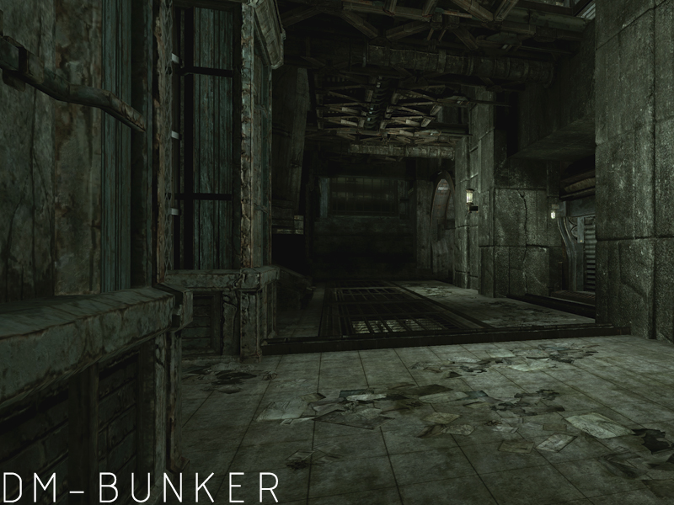

Section X: Sound / Soundtrack and Music

10.1 Sound style: The overall feel of the sounds will be polished, but not too complex. A good comparison would probably be a mix between the audio of current-gen Mario games and Braid. Though the tone is often playful and never takes itself too seriously, at times it does command a sense of ambience and even dread.

10.2 Interesting soundtrack details: There will be two complete scores for the game (every level, every menu, even the credits)—one for Lawrence and one for Lily. Though the melodies and chord progressions for both will be nearly the same, the overall feel and mood (including tempo and even major-minor key) will be different, giving each soundtrack a distinct feel. The cool thing about this is that, just like the art style and visual presentation, the music swaps between the associated scores in real-time as characters are swapped. Though tempos and other details may vary slightly between the characters’ scores, this effect will still be accomplished successfully by tagging hundreds of time points within each song to match the associated time point in its counterpart. To further blend the song swapping, a slight moment of pitch-bend and distortion will stretch through the character-swap. Besides masking any inconsistency or jarring between the two characters’ soundtracks, this will also act as an audio cue/sound effect for the character-swap.

10.3 Sound effects: Like the music, sound effects will be individualized to each character, including grunts, yelps, damage sounds, enemy vocalizations, environmental ambience, etc.

